Đặng Hoàng Nguyên - SE171946

**What is lsass.exe? In what folder is it located?**

It stands for Local security Authority Process, in C:\Windows\System32\lsass.exe

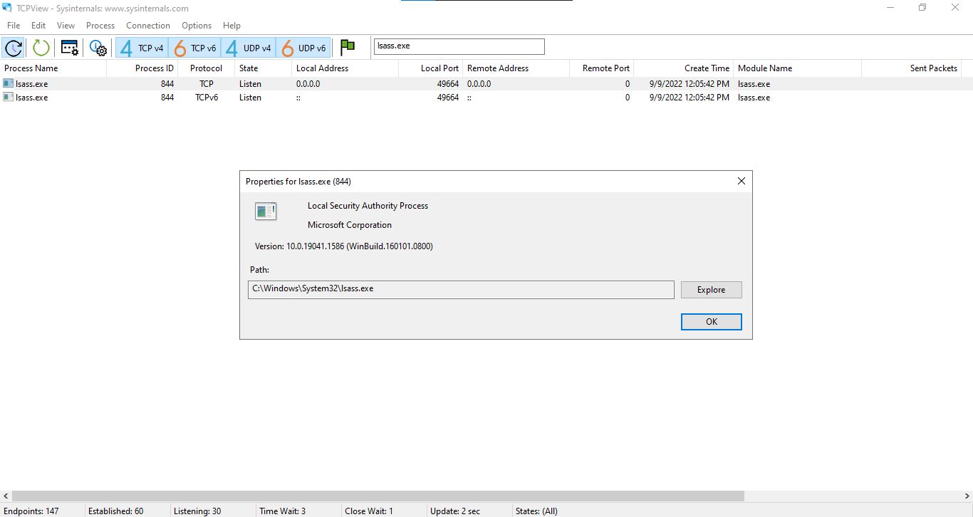

**What did you observe in the TCPView window?**

The processes of Edge are added to TCPView window

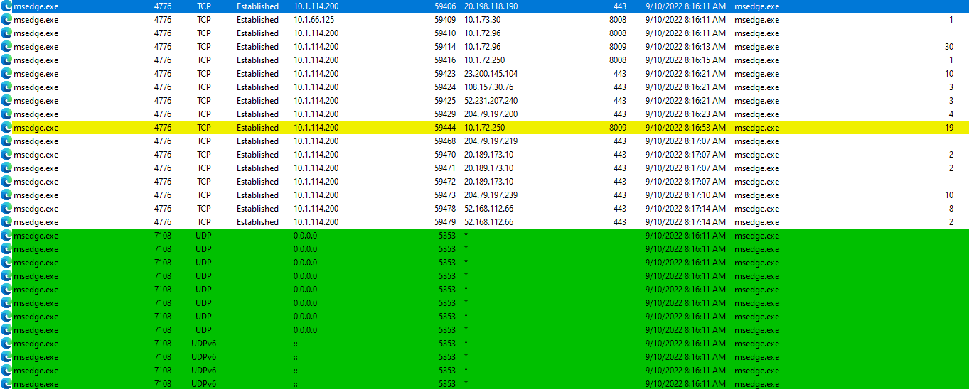

**What did you observe in the TCPView window when closing window?**

The processes for Edger will be removed from the TCPView window.

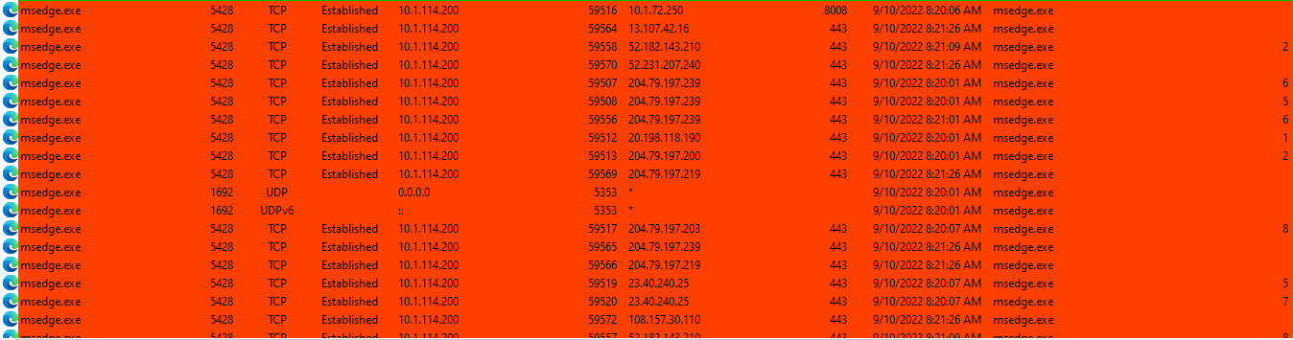

**Reopen the web browser. Research some of the processes listed in TCPView. Record your findings**

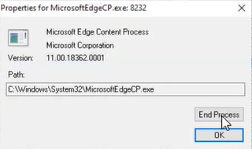

Most of these listed resources are located in the C:\Windows\System32\folder. EX: MicrosoftEdgeCP.exe. These executables could constitute malware, such as viruses, spyware, trojans, or worms, if they are discovered in other parts of the system.